**1. Display greet message using the system time.**

**2. Find the factorial of a given number.**

**3. Generate the fibonacci series for the number of terms entered by the user.**

**4. To print the number table.**

**5. To display square of first 20 numbers.**

**6. To print the largest of 3 numbers entered by the user.**

**7. To reverse a number.**

**8. To reverse a string.**

**9. Check whether the entered number is odd or even.**

**10. Check Whether given year is leap year or not.**

**11. To print all the prime numbers less than 20.**

**12. To check if the entered string is palindrome or not.**

**13. Using switch case print the capitals given the state name.**

1. **Write shell script to generate following series: 20, 22, 18, 20, 16, 18, 14, 16.**

**15. Append content to a file provided file name exists and it has write permission.**

**16. Generate the series: 1,3,2,4,3,5,4,6,.....**

1. **Write a shell script to prompt user to enter 2 numbers and perform various arithmetic operations using switch statement.**
2. **To sort given numbers in descending order.**
3. 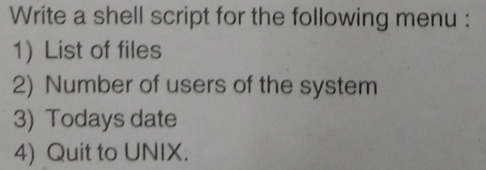
4. 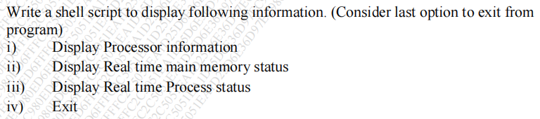
5. 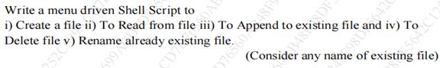
6. 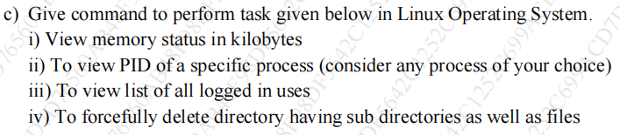

23. Display the following patterns :

**\* * * * \***

**\* * * \***

**\* * \***

**\* \***

**\***

**1 2 3 4**

**2 3 4**

**3 4**

**4**

**1**

**2 2**

**3 3 3**

**4 4 4 4**